VPC TASK

1. Same region TGW

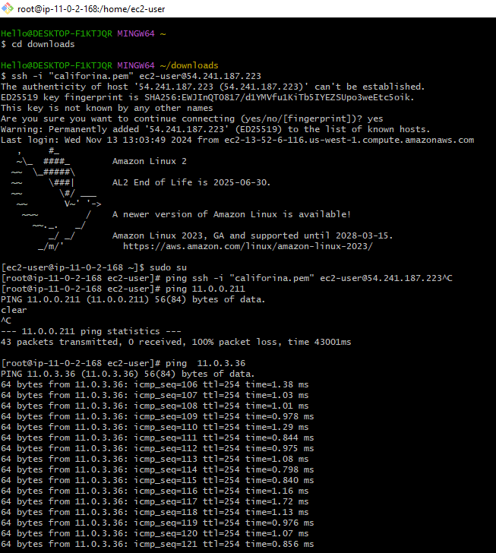

1. Configure VPC endpoints to securely access AWS services without internet gateways or NAT gateways, ensuring data privacy and minimizing exposure to external threats.

